**Unit 4**

**Oracle Architecture**

Oracle Database is a relational database management system (RDBMS) that Oracle Corporation created and marketed. It is one of the most popular RDBMSs on the market and is used to store and retrieve data for a wide range of applications. Oracle Database is well-known for its dependability, scalability, and performance, and it is compatible with a wide range of programming languages and development frameworks. It includes data warehousing, online transaction processing, and advanced analytics, as well as high availability, disaster recovery, and security.

The oracle database architecture consists of:

* Memory structure(Instances)
* Database system
* Processes

**Oracle Instances**

The instance is a collection of two things:

**SGA:** It stands for System Global Area. It is a shared memory area.  Whenever a database instance starts, some memory gets allocated and that memory is termed SGA. Along with memory allocation, one or more background processes will. SGA is used to store data as well as control information about one database instance through its various subcomponents, Where each component is dedicated to a specific purpose. Various Components are:

* **Database buffer cache:** The Buffer Cache is a portion of the SGA that stores copies of data blocks read from datafiles. It is used to cache frequently accessed data blocks, reducing the number of disks I/Os required to access the data. This can improve performance by reducing disk I/O time and increasing the speed of data retrieval.
* **Redo log Buffer:** The most crucial structure for recovery operations is the redo log, which consists of two or more preallocated files that store all changes made to the database as they occur. Every instance of an Oracle Database has an associated redo log to protect the database in case of an instance failure.
* **Java pool:** The Java Pool is an optional portion of the SGA that is used by Java Virtual Machine (JVM) and related components. It is used to store Java-related data structures, such as Java classes and objects. This pool is used when the Oracle Database is configured to run Java applications or when using Oracle JVM.
* **Large Pool:** The Large Pool is an optional portion of the SGA that can be used for large memory allocation, such as backup and restore operations and I/O server processes. It is typically used to improve the performance of these operations by reducing the amount of disk I/O required.
* **Shared pool:** The Shared Pool is a portion of the SGA that contains shared memory structures, such as shared SQL and PL/SQL areas. It is used to store the parsed representation of SQL statements, execution plans, and PL/SQL program units. This allows for the efficient reuse of frequently executed statements, reducing the need for reparsing and improving performance.

**Background processes:** Oracle has a collection of processes that are called background processes. These processes are responsible for managing memory, performing I/O operations, and other maintenance activities.  Following are some important background processes that are required:

* **System Monitor Process (SMON)**: These processes are responsible for performing system-level recovery and maintenance activities.
* **Process Monitor Process (PMON):** The task of these processes is to monitor other background processes.
* **Database Writer Process (DBWR):** This process performs the task of writing data blocks from the Database Buffer Cache (present in SGA) to physical data files(Present in the Database system).
* L**og Writer Process (LGWR):** This process writes the Redo blocks from Redo Log Buffer (present in SGA) to Redo Log Files(present in the Database system).
* **CheckPoint (CKPT):** This process maintains data files and control files with the most recent checkpoint information.

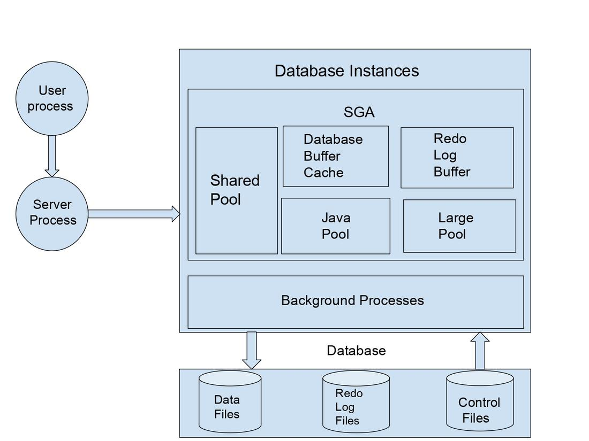

**Database System**

The database system is suited to the storage system of a computer. The Database system is simply the storage of files. There are three categories of files that are situated in the database system and those are:-

* **Data files:** These files hold the actual data in the database.
* **Redo log files:** These files are used to hold the changes made in the database. Redo log files can be utilized during the database recovery process to retrieve the original information.
* **Control files:** It is a binary file that holds database status-related information like Database Name, Data File, and Redo Log file Names, File Locations, and Log Sequence Number.

There are other categories of files that contribute to database management.

* **Parameter file:** This file contains the parameters which define the way the database is expected to start up.
* **Password file:** This file holds the user passwords and thus maintains the security of databases.

**Processes**

There are two types of processes:

* **User process:** It is also known as the client process The user actually connects to the instance with the help of user processes.   
  the user process is stabilized when the user sends a connection request to the oracle server.
* **Server process:** The server Process connects the user to the database and performs the activities on the client’s behalf as executing SQL statements or retrieving data from the database.

**\*\*\*Database startup and shutdown types:**-

**Startup Modes:**

* **Normal Startup (Open):** Starts the database instance fully, allowing immediate user access.
* **Mount Only:** Starts the instance, mounts the database, but does not open it, allowing for certain administrative tasks.
* **Nomount Startup:** Starts the instance without mounting a database, used for database creation or control file recovery.
* **Restricted Mode:** Starts the database with limited access, typically only for database administrators.

**Shutdown Modes:**

* **Normal Shutdown:** Gracefully shuts down the database, ensuring all active transactions are completed and users are disconnected.
* **Immediate Shutdown:** Forces the database to shut down immediately, potentially causing data loss if active transactions exist.
* **Abort Shutdown:** Stops the database abruptly, often used in emergency situations

**** Back up and Recovery

A database backup is a copy of storage that is stored on a server. Backup is used to prevent unexpected data loss. If original data gets lost, then with the help of a backup, it is easy to gain access to the data again.

There are two types of database backup.

* Physical backup
* Logical backup

**Physical Backup:**

Physical database backups are backups of physical files that are used to store and recover databases. These include different data files, control files, archived redo logs, and many more. Typically, physical backup data is kept in the cloud, offline storage, magnetic tape, or on a disc.

There are two methods to perform a physical backup :  
1. Operating system utilities  
2. Recovery manager 

This type of backup is useful when the user needs to restore the complete database in a short period. It is beneficial to provide details of transactions and changes made in databases. It is considered the foundation of the recovery mechanism. This form of backup has the drawback of slowing down database operations.

**Advantages:**

* It is useful when the user needs to restore the complete database in a short period.
* They provide details of transactions and changes made in databases.

**Disadvantage:**

* This slows down database operations.

**Logical Backup:**

It contains logical data which is retrieved from the database. It contains a view, procedure, function, and table. This is useful When users want to restore or transfer a copy of the database to a different location. Logical backups are not as secure as physical backups in preventing data loss. It only provides structural details. Every week, complete logical backups should be performed. Logical backups are used as a supplement to a physical backup.

**Advantages:**

* This is useful when the user needs to restore the complete database to the last time.
* It was more complex and provides granular recovery capabilities.

**Disadvantages:**

* Critical for recovery of special components.
* less secure compared to physical backup.
* It only provides structural details.

**Physical Backup Vs Logical Backup:**

| **Physical Backup** | **Logical Backup** |
| --- | --- |
| Physical database backups are backups of physical files that are used to store and recover databases. | Logical database backups are backups of logical files that are retrieved from the database. |
| It contains data files, control files, and archived redo logs. | It contains a view, a procedure, a function, and a table. |
| It copies data files when data is running or stopped. | Using the EXPORT keyword Logical backup is done |
| A user needs to restore the complete database in a short period of time. | This is useful when users want to restore or transfer a copy of the database to a different location. |
| More secure than logical backup. | Less secure as compared to Physical backup. |